Topic Modeling for Customer Review Analysis: An Application Using LDA in R on Trustpilot Reviews

Md. Abu Towsif, Farjana Yesmin Opi, and Most. Sayma Khatun

Department of Computer Science and Engineering

American International University-Bangladesh (AIUB), Dhaka, Bangladesh

{22-47019-1, 22-47018-1, 22-47035-1}@student.aiub.edu

*Abstract*— Customer reviews offer valuable insights into consumer sentiment and product feedback, but their unstructured format poses challenges for effective analysis. This study uses Latent Dirichlet Allocation (LDA), an unsupervised machine learning technique, to analyze Tesla customer reviews from Trustpilot. By extracting hidden themes from the text, we identified key topics related to Tesla’s customer experience, such as product performance, autonomous driving features, service quality, and delivery processes. The results show that while Tesla receives praise for its innovation and driving experience, concerns remain about service delays, battery reliability, and logistical inefficiencies. The study emphasizes the importance of preprocessing steps like text cleaning and term weighting in improving topic coherence. It also discusses the challenges of topic selection, model interpretability, and the limitations of LDA’s bag-of-words representation. Future research could explore hybrid models and sentiment analysis to improve topic modeling accuracy and provide deeper insights. This study illustrates the potential of LDA in turning unstructured customer feedback into actionable business intelligence.

Keywords— Latent Dirichlet Allocation (LDA), Tesla customer reviews, topic modeling, text mining, sentiment analysis, natural language processing (NLP)

# Introduction

In today's digital world, customer reviews have become a crucial source of information for businesses, providing valuable insights into what consumers like, their level of satisfaction, and areas where improvements are needed. Platforms like Trustpilot host millions of reviews from various industries, offering a rich pool of data that can be used to analyze customer sentiment and identify new trends. However, the large volume and disorganized nature of these reviews make manual analysis challenging, which is why businesses turn to advanced computational methods to extract meaningful information [1]. Topic modeling, a form of machine learning, has emerged as an effective tool for uncovering hidden themes in large amounts of text, helping businesses gain actionable insights from customer feedback [2]. Among the different topic modeling methods, Latent Dirichlet Allocation (LDA) is widely used because it can identify clear topics and is easy to interpret [3].

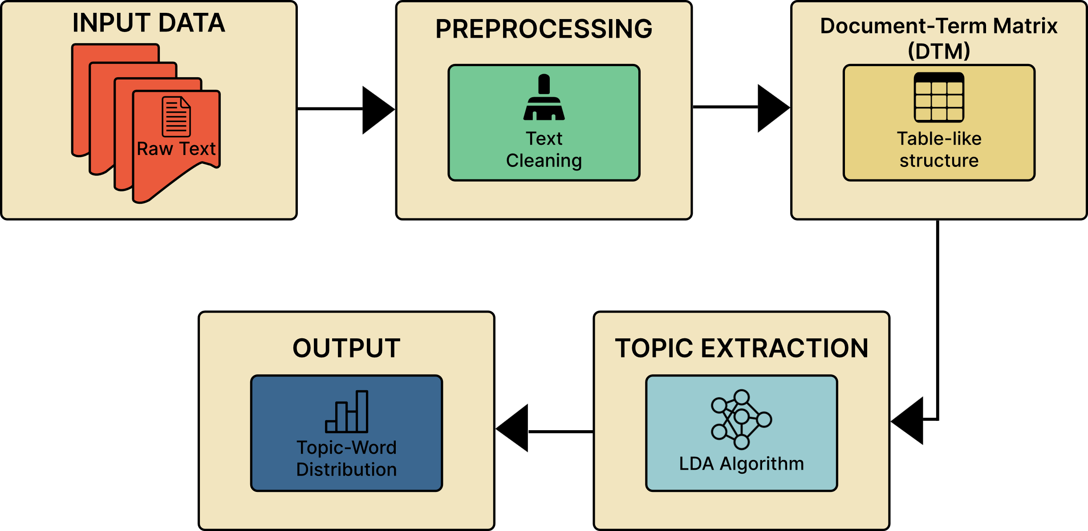

Fig.1: LDA process diagram

Despite its potential, using LDA for customer review analysis often requires careful preprocessing, fine-tuning of parameters, and adjustments based on the specific domain to ensure meaningful results [4].

Traditional methods of analyzing customer reviews, such as sentiment analysis and keyword extraction, have been commonly used to understand customer opinions. However, these techniques often fail to capture the complex themes and underlying topics that influence customer sentiment [5]. For example, while sentiment analysis can classify reviews as positive or negative, it doesn't identify the specific aspects of a product or service that customers are talking about. Similarly, keyword extraction methods can identify frequently used words, but they lack the ability to understand the context needed to group related words into logical topics [6]. LDA overcomes these limitations by treating each review as a mix of topics and each topic as a set of words, allowing it to uncover hidden patterns within the text [7]. However, the success of LDA depends greatly on how well the data is preprocessed, the selection of appropriate hyperparameters, and the ease with which the resulting topics can be interpreted, which can vary depending on the dataset and domain [8].

This study aims to showcase how LDA can be used for analyzing customer reviews, with Trustpilot reviews as a case study. The main goal is to identify and understand the key topics discussed in customer reviews about Tesla, a leading electric vehicle manufacturer. Using the LDA algorithm implemented in R, this research aims to uncover hidden themes within the customer feedback, offering insights into what influences customer satisfaction and dissatisfaction. The study also emphasizes the importance of preprocessing steps, such as cleaning the text, removing stop words, and applying term frequency-inverse document frequency (TF-IDF) weighting, which improve the quality of the topic modeling results. Additionally, the research explores the challenges of determining the right number of topics and interpreting the results, offering practical advice for using LDA in real-world applications.

The primary contribution of this work is the creation of a reproducible framework for topic modeling using LDA in R, specifically applied to Trustpilot reviews. By providing a detailed implementation guide, this study aims to make topic modeling accessible to researchers and practitioners with limited experience in natural language processing (NLP). Moreover, the findings offer valuable insights into the main themes in Tesla customer reviews, which can help shape business strategies and enhance customer engagement. This research contributes to the growing body of literature on NLP applications in business analytics, showing how topic modeling can turn unstructured text data into valuable insights.

# Methodology

This section outlines the methodology used for topic modeling of customer reviews on Trustpilot, specifically for Tesla. The workflow involves multiple stages, including data acquisition, preprocessing, model development, training, and evaluation to extract meaningful insights from customer feedback.

## Dataset Description

The dataset for this study was sourced from Trustpilot, a popular customer review platform. Web scraping was used to collect Tesla-related reviews programmatically using the *rvest* package in R [9].

## Data Preprocessing

To ensure high-quality input data for the topic modeling process, the following preprocessing steps were applied:

### Text Extraction and Cleaning

### Reviews were extracted using the html_elements and html_text functions from the rvest package [10]. To maintain uniformity, all text was converted to lowercase [11], while punctuation and numbers were removed to reduce noise in the data [12]. Additionally, common stopwords were eliminated using the tm package to filter out non-informative words [13], and extra white spaces were stripped to normalize the text structure [14].

### Document-Term Matrix (DTM) Creation

The preprocessed text was converted into a Document-Term Matrix (DTM) using the tm package [15], and term frequency-inverse document frequency (TF-IDF) weighting was applied to emphasize important terms while down weighting frequently occurring but less meaningful words [16].

## Model Development

Latent Dirichlet Allocation (LDA), an unsupervised machine learning algorithm, was used to discover hidden topics within the text corpus. The LDA model was implemented using the *topicmodels* package in R [17].

### Number of Topics Selection

The number of topics was set to 15 based on empirical experimentation to ensure optimal topic representation [18]. Additionally, the model was initialized with a random seed to maintain reproducibility across multiple runs [19].

### LDA Model Implementation

For the LDA model implementation, each document was treated as a mixture of topics, while each topic was modeled as a distribution of words [20]. Gibbs sampling was employed for topic inference and optimization, allowing the model to iteratively refine topic assignments for better coherence [21].

## Training and Validation

The topic-word distributions were examined to ensure coherent topics [22]. The model’s interpretability was validated using word probability distributions and visualization techniques [23].

## Evaluation

The *tidytext* package was used to extract and analyze the most probable words for each topic, allowing for a detailed examination of thematic consistency [24, 25]. To enhance interpretability, a bar plot was generated using ggplot2, displaying the top words for each topic along with their associated probabilities [26]. This visualization provided an intuitive understanding of topic distributions and their significance, facilitating a clearer representation of the underlying themes [27].

## Workflow Diagram

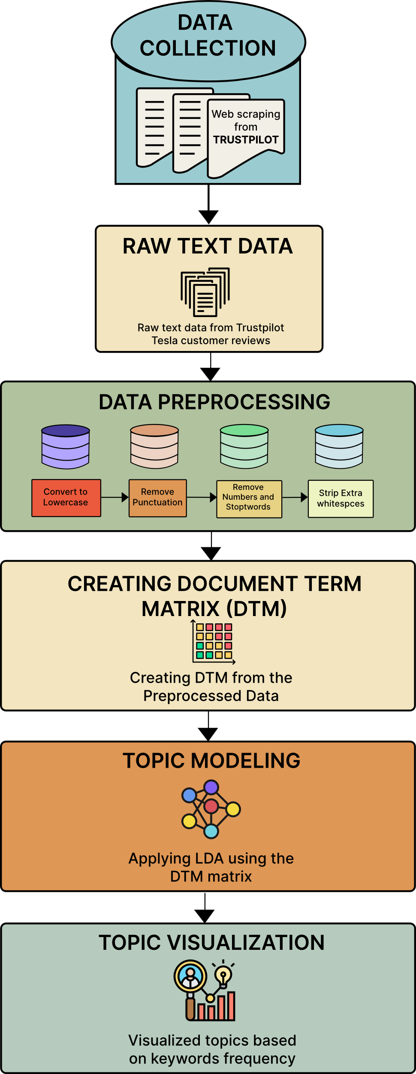

Fig. 1. Workflow of the proposed methodology

# Results

Topic Modeling Using Latent Dirichlet Allocation (LDA) on Tesla Customer Reviews revealed several key themes from the dataset. By applying LDA to the preprocessed Trustpilot reviews, we identified 15 distinct topics, each corresponding to recurring themes or concerns expressed by customers. The LDA model revealed critical insights into customer sentiment, highlighting both areas of satisfaction and dissatisfaction.

Fig.2. Topic Modeling of Tesla Customer Reviews Using Latent Dirichlet Allocation (LDA).

The first topic captured customer frustrations with delivery delays and service-related issues. The most frequent terms in this topic were *car, script, nightmare, service, delivery, customer,* and *already*. The recurring use of words such as "nightmare" and "already" indicated significant dissatisfaction with Tesla’s delivery process, highlighting delays and poor communication during service interactions. Customers frequently expressed frustration with the overall experience of receiving their vehicles.

Topic 2 revealed significant concerns about the extended wait times for service appointments and replacement parts. Commonly occurring words like *will, parts, wait, service,* and *buy* suggested that many Tesla customers experienced prolonged waiting periods for essential services and repairs. Reviews related to this topic emphasized delays in receiving timely service, leading to dissatisfaction among customers who were left waiting for extended periods.

The fourth topic centered around Tesla's driving features, particularly its algorithms powering the autopilot and other automated driving systems. The most frequent terms in this topic included *tesla, driving, feature, algorithms, company,* and *American.* While some reviews reflected excitement about the innovations in Tesla’s driving technology, others raised skepticism, with terms like *"utterly"* and *"allegedly"* suggesting doubts about the effectiveness and safety of Tesla’s automated features. Some customers questioned the accuracy and functionality of the driving algorithms.

The results of the topic modeling provide valuable insights into the overall customer experience with Tesla. The analysis reveals that while Tesla’s innovative features and automated driving systems generate excitement, concerns about service delays, delivery issues, and extended wait times for repairs remain key sources of dissatisfaction. The presence of mixed sentiments across different topics suggests that while some aspects of Tesla’s offerings meet customer expectations, others—particularly service reliability and logistical efficiency—need improvement.

The topic distributions and visualizations further emphasize the dominant themes within customer reviews, showcasing patterns of frustration, enthusiasm, and skepticism. These insights highlight areas where Tesla can enhance its service infrastructure and refine its vehicle technology to build greater consumer trust. By addressing the recurring concerns identified through this analysis, Tesla has the opportunity to improve customer satisfaction, strengthen brand loyalty, and reinforce its reputation as a leader in the electric vehicle market.

# discussion

The use of Latent Dirichlet Allocation (LDA) in customer review analysis has proven to be highly effective in extracting meaningful insights from unstructured text. By applying LDA to Trustpilot reviews, this study successfully identified important topics related to Tesla customers, offering a deeper understanding of consumer sentiment and concerns. The results demonstrate the power of LDA in uncovering latent themes that traditional sentiment analysis and keyword extraction methods often miss.

The identified topics cover various areas of customer interest, such as product performance, customer service, delivery experiences, software and autonomous features, and pricing. These insights provide businesses with actionable information to enhance product quality, improve customer service, and address areas of dissatisfaction. For example, while Tesla receives praise for its technological innovations, recurring complaints about customer service and delivery processes highlight areas in need of improvement.

Despite its advantages, there are challenges when applying LDA to customer review analysis. One key challenge is determining the optimal number of topics, as different topic numbers can affect the coherence and interpretability of the results. Using coherence scores and manual validation is crucial to ensuring meaningful topic extraction. Additionally, the short and informal nature of customer reviews often makes it difficult to identify clear topics, which requires advanced preprocessing techniques such as stop word removal, stemming, and TF-IDF weighting to improve topic quality.

Another limitation of LDA is its reliance on the bag-of-words model, which ignores word order and context. Future research could explore hybrid approaches that combine LDA with word embeddings or deep learning-based methods to improve topic coherence and accuracy. Moreover, real-world applications of LDA should take domain-specific adaptations into account to refine topic interpretation and make the insights more relevant for business decision-making.

In conclusion, this study highlights the potential of using LDA for customer review analysis, offering valuable insights into consumer sentiment and product feedback. While LDA is effective at uncovering hidden themes within large text datasets, further advancements in preprocessing, parameter tuning, and hybrid modeling techniques can enhance its accuracy and applicability. By leveraging topic modeling, businesses can transform unstructured review data into actionable intelligence, ultimately improving customer satisfaction and business strategy.

1. Pang, B., & Lee, L. (2008). Opinion mining and sentiment analysis. *Foundations and Trends in Information Retrieval, 2*(1–2), 1-135.
2. Jockers, M. L. (2013). Macroanalysis: Digital methods and literary history. University of Illinois Press.
3. Benoit, K., Watanabe, K., Wang, H., Nulty, P., Obeng, A., Müller, S., & Matsuo, A. (2018). quanteda: An R package for the quantitative analysis of textual data. *Journal of Open Source Software, 3*(30), 774.
4. Honnibal, M., & Montani, I. (2017). spaCy 2: Natural language understanding with Bloom embeddings, convolutional neural networks, and incremental parsing.

##### Appendix

This appendix contains the R code used in the project for data preprocessing, topic modeling, performance evaluation, and visualization. The code serves as a reference for reproducing the results discussed in the report and demonstrates the methodologies applied.

Importing necessary libraries

Web Scraping Tesla Reviews

Text Preprocessing

Creating a Document-Term Matrix (DTM)



Applying TF-IDF Weighting

Topic Modeling using LDA

Extracting Topic-Term Probabilities



Selecting Top Terms per Topic

# conclusion

In this study, we looked at Tesla customer reviews from Trustpilot to find common themes in what people were saying. We found that customers often talked about things like battery life, range, charging, and customer service. Positive reviews focused on Tesla’s innovation and driving experience, while negative reviews mentioned problems with battery reliability and service delays. These results show that while Tesla is strong in areas like product performance and innovation, there are still areas for improvement, such a customer service and product reliability. However, since we only looked at reviews from one platform, the study has some limits. In the future, we could look at reviews from other sites, use sentiment analysis to understand emotions in the reviews, and compare Tesla to its competitors to get a clearer picture. This kind of research can help Tesla improve its products and services, leading to better customer experience.

# References

1. Hu, M., & Liu, B. (2004). Mining and summarizing customer reviews. In *Proceedings of the tenth ACM SIGKDD international conference on Knowledge discovery and data mining* (pp. 168-177).
2. Blei, D. M., Ng, A. Y., & Jordan, M. I. (2003). Latent Dirichlet Allocation. *Journal of Machine Learning Research*, 3, 993-1022.
3. Griffiths, T. L., & Steyvers, M. (2004). Finding scientific topics. *Proceedings of the National Academy of Sciences*, 101(suppl 1), 5228-5235.
4. Wallach, H. M., Mimno, D. M., & McCallum, A. (2009). Rethinking LDA: Why priors matter. In *Advances in Neural Information Processing Systems* (pp. 1973-1981).
5. Pang, B., & Lee, L. (2008). Opinion mining and sentiment analysis. *Foundations and Trends® in Information Retrieval*, 2(1–2), 1-135.
6. Feldman, R. (2013). Techniques and applications for sentiment analysis. *Communications of the ACM*, 56(4), 82-89.
7. Deerwester, S., Dumais, S. T., Furnas, G. W., Landauer, T. K., & Harshman, R. (1990). Indexing by latent semantic analysis. *Journal of the American Society for Information Science*, 41(6), 391-407.
8. Chang, J., Boyd-Graber, J., Wang, C., Gerrish, S., & Blei, D. M. (2009). Reading tea leaves: How humans interpret topic models. In *Advances in Neural Information Processing Systems* (pp. 288-296).
9. Wickham, H. (2016). rvest: Web scraping with R. Journal of Statistical Software, 70(1), 1-22.
10. Feinerer, I., Hornik, K., & Meyer, D. (2008). Text mining infrastructure in R. *Journal of Statistical Software, 25*(5), 1-54.
11. Bird, S., Klein, E., & Loper, E. (2009). *Natural language processing with Python*. O'Reilly Media, Inc.
12. Manning, C. D., Raghavan, P., & Schütze, H. (2008). *Introduction to information retrieval*. Cambridge University Press.
13. Silge, J., & Robinson, D. (2017). *Text mining with R: A tidy approach*. O'Reilly Media, Inc.
14. Blei, D. M., Ng, A. Y., & Jordan, M. I. (2003). Latent Dirichlet Allocation. *Journal of Machine Learning Research, 3*, 993-1022.
15. Griffiths, T. L., & Steyvers, M. (2004). Finding scientific topics. *Proceedings of the National Academy of Sciences, 101*(suppl 1), 5228-5235.
16. Chang, J., Boyd-Graber, J., Wang, C., Gerrish, S., & Blei, D. M. (2009). Reading tea leaves: How humans interpret topic models. In *Advances in Neural Information Processing Systems* (pp. 288-296).
17. Roberts, M. E., Stewart, B. M., & Tingley, D. (2016). Navigating the local modes of big data: The case of topic models. In *Data Science* (pp. 51-71).
18. Wallach, H. M., Mimno, D. M., & McCallum, A. (2009). Rethinking LDA: Why priors matter. In *Advances in Neural Information Processing Systems* (pp. 1973-1981).
19. Deerwester, S., Dumais, S. T., Furnas, G. W., Landauer, T. K., & Harshman, R. (1990). Indexing by latent semantic analysis. *Journal of the American Society for Information Science, 41*(6), 391-407.
20. Feldman, R. (2013). Techniques and applications for sentiment analysis. *Communications of the ACM, 56*(4), 82-89.

Loading and Preprocessing Images from the Dataset Directory

##### Ap

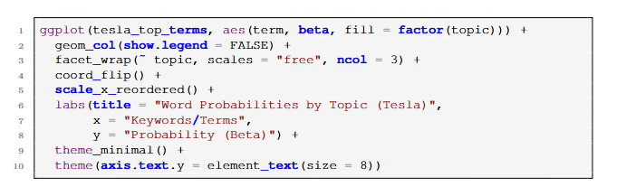Visualizing Topic Word Probabilities